Instructions on how to run my back-end application(Screenshots included)

- Unzip the folder that you have downloaded, and save it in your C drive (C:)
_________________________________________
_________________________________________

- Open the folder containing all the files, using visual studio, or other preferred editor.
_________________________________________
_________________________________________
_________________________________________

- Now you are ready to start the localhost. If haven’t already make you sure you install the following the required extensions, such as nodemon, express, mongoose, and body-parser.
_________________________________________
_________________________________________
_________________________________________

- Open the terminal window, and run “nodemon server.js” to start the server on localhost port 3000.

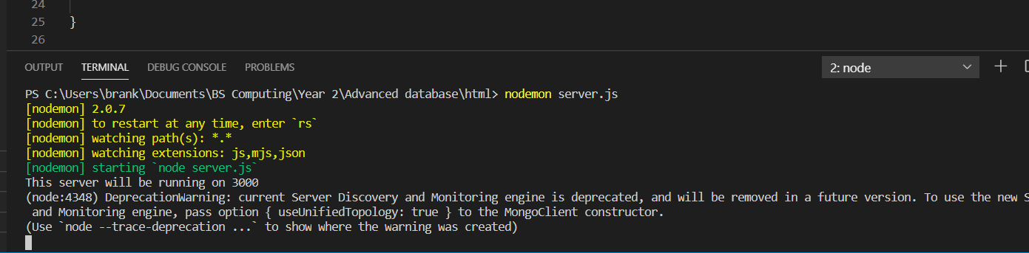

- The server is operating, so open your browser, and type localhost:3000 to open the html using the server.

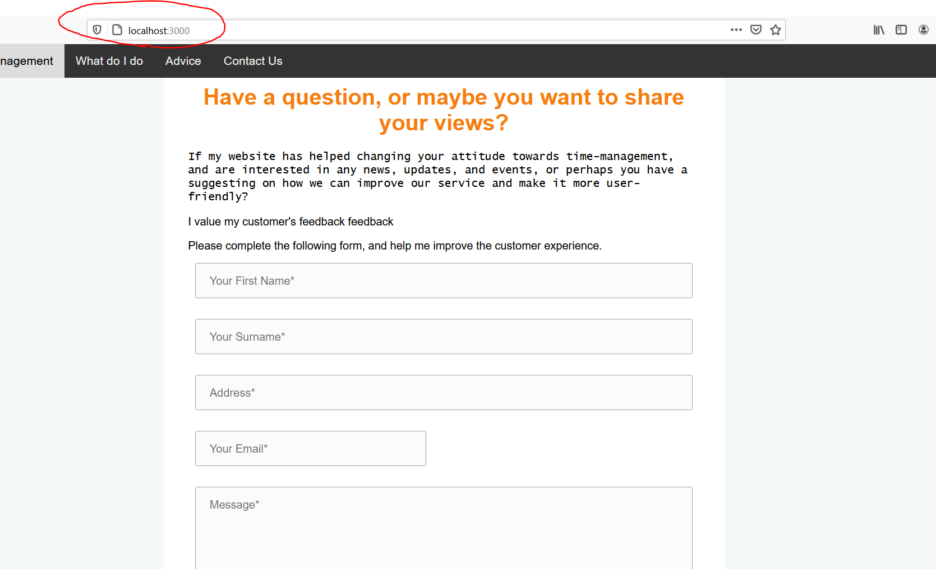
___________________________________________________________________________________________________________________________________________________________________
- Fill in the required details in the form, and press “submit” to send your details to the database.
